**Name – S.M.J.B.Nelugolla Registration no – IT19209562**

My functions are Item management, Shopping cart and delivery. Item management is done by an admin in the system. There the admin can add, update, delete items after logged as an admin to the system. Users can filter the items according to the brand, size and color to buy them. If there are more than one item users should select the items to be in the cart and finally pay them.

* Confirmation message : When admin add, update items to the system.
* Alert : When admin delete some items from the system.

**Wireframes**

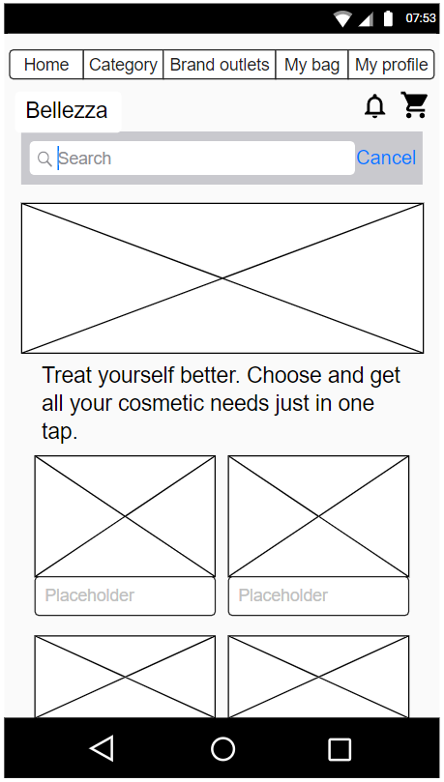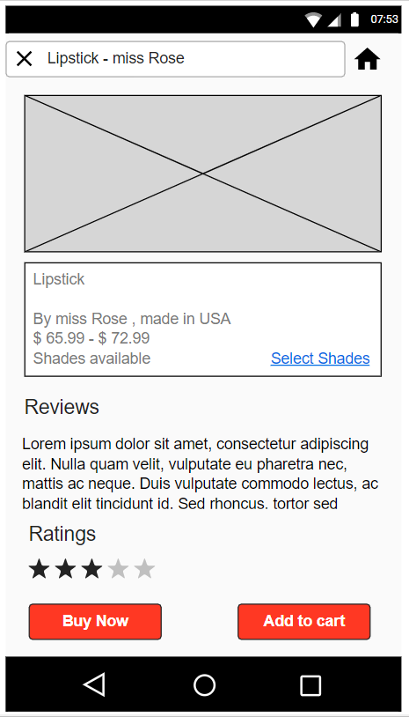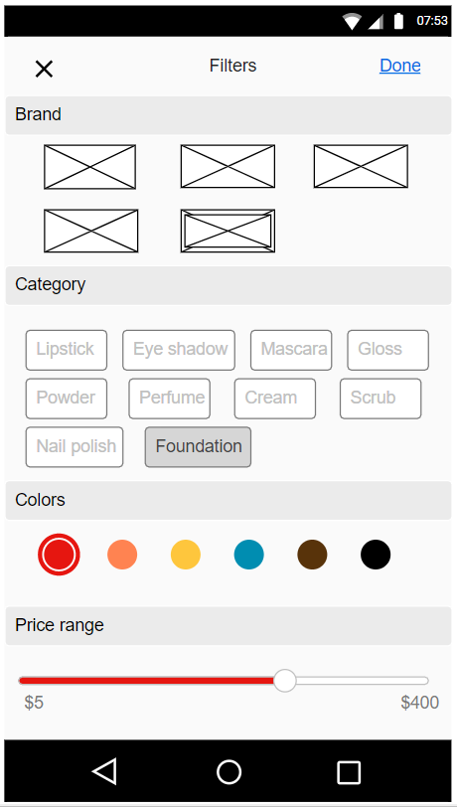 1.0) 1.1) 1.2)

1.0) Users can search and select the items to be bought. Items can be selected through the categories too.

1.1) User can view the item details in this page, reviews of the other customers , ratings and price details are there in this page.

1.2) User can go to the “filters page” by clicking the “select shades” in the (1.1) page. After selecting the brand, category and color the user will be directed to the previous page by clicking “done”.

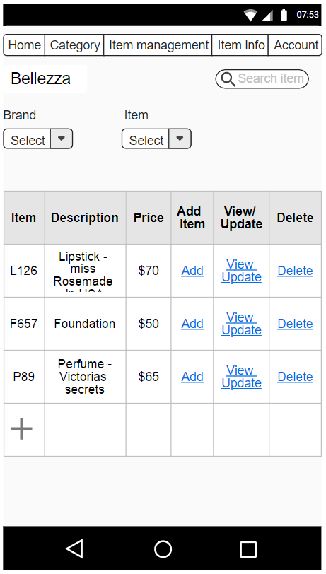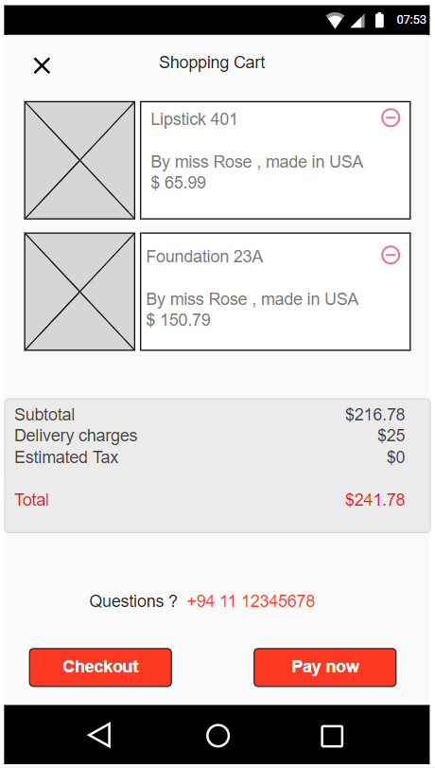 2.0) 3.0)

2.0) all the added items will be shown in the shopping cart. There the user can remove the selected items which are not necessary. And the user can check the item details again by clicking “checkout “. Then the user will be directed to (1.1) again to see the item details. By clicking the “pay now” button, user will be directed to the payment section.

3.0) this is the page of item management which can be accessed only by admins. Previously added items can be viewed by filtering with brand or category (item).